CpSc 372
Exam 1

Name______________________________________________

Answer any FOUR of the five questions. Place a large X on the question you are omitting. If you answer all five, the one on which you score the best will be dropped. All questions are counted the same: 25 points each. Answer all parts of each question. By signing your name below you acknowledge that you have neither given nor received help on this exam by any means other than those described to you. You are not allowed to browse the internet nor are you allowed to send/receive any email.

signature

- Modeling
- Three criteria for a good model are: complete, consistent, and correct. What does it mean for a use case diagram to be complete, correct and consistent?

- We have used the state diagram of the UML modeling language to model the phases of a traffic intersection. How can we ensure that the green light is not lit on all sides at the same time?

- We looked at the sequence diagram as supplementing the use case diagram. How does it do that? What is in a sequence diagram that is not in a use case?

- What is the correspondence between the elements of a sequence diagram and a class diagram.

- Design decisions
- We have addressed several design actions so far. Select one specific design rule that was applied to our design to modify the product and describe how it makes a complex design less complex.

- How would your action from #2a be implemented?

- A tradeoff considers both the things that are improved by a design decision and the things that are degraded. In one of our examples, we separated a system into two different blocks in our block diagram: client and server. What about the design was improved by doing this and what was degraded?

- Describe one means of applying the open/closed principle.

- Domain modeling
- How can the criteria in #1a be used to evaluate a domain model for your application domain?

- We first model “sunny day” scenarios, where everything goes well, for each use case and then added the “rainy day” scenarios where there is some error. Why not do both at the same time?

- In a software product line we have two levels of models: product line and product. Explain what the difference is between the product line architecture and product-specific architecture.

- For the Android app domain list two potential non-functional requirements. Briefly describe how each can be satisfied thru design.

- Process Modeling
- We talked about several process models: waterfall; iterative, incremental; agile; and others. List at least three factors that help decide which of these to use. Explain why each is a valid criterion for the decision of which process model to use.

- The picture of RUP shows “iteration”s across the bottom and phases across the top, both along the horizontal axis, and disciplines on the vertical axis. What is the relationship between the vertical and horizontal axes? How is that relationship represented?

- The SPEM standard identifies Roles, Tasks, Workproducts, and Guidance as the fundamental elements for a process. Take one phase of the RUP and give examples for each of the four SPEM categories for that phase.

- Explain how that Role you selected in (c) above contributes to the success of the development of a product.

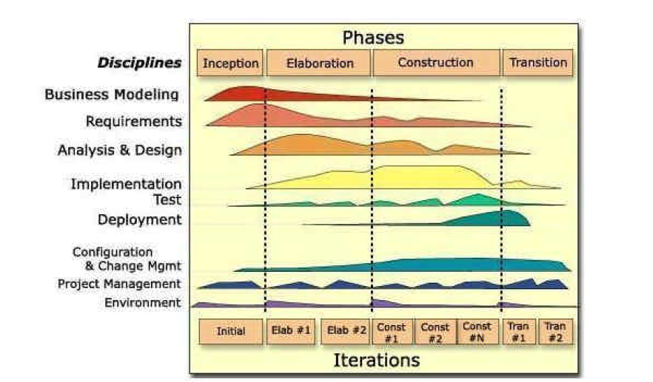

- Architecture
- The quality attributes we choose for our project gave a basis for making design decisions. Describe one design choice that you made based on one of the high priority quality attributes. What were the alternatives that you considered in addition to the design you chose?

- We use scenarios in the elicitation of requirements and for the evaluation of a design. What is the same about these two types of scenarios and what is different? (Note – defining each type does NOT answer what is different.)

- With every design decision we make we have an accompanying risk that we have made a wrong decision. What actions do we take in our development process to mitigate that risk?

- When is it appropriate to use the layered architecture style? Which qualities does the style enhance and which does it degrade?

