CpSc 871
MidTerm Exam

Name________________________________

Answer any FOUR of the five questions. Place a large X on the page for the question you are not answering. If you answer all five, I will eliminate the one on which you did the best. All questions are counted the same: 25 points each. Be certain to answer ALL parts of the questions you select to answer. Answer the question that is asked and then stop. You are allowed the notes you have taken and printouts but no laptops.

- We have discussed several basic architecture styles.
  - Why did we use the MVC style for our computation application? In other words, which quality attributes were enhanced and which were degraded?
  - How does a layered architecture style enhance modifiability?
  - Describe one architectural view of our sample computational problem? Explain why that view is useful to the architect and to the person writing the code.
  - For a particular design problem there are usually several styles that will work. Describe the method for making a choice. What are the roles, tasks, and work products associated with that method of decision making?

- Requirements elicitation
  - Why is a use case approach to requirements elicitation better than the traditional approach of writing individual statements?
  - Why is it important to include many different stakeholders in the elicitation process?
  - Who would be the highest priority stakeholder for the computational system example? Why?
  - For purposes of security there is a requirement that all login mechanisms must use the same table of authorized users. How does this requirement flow from requirements to architecture design and on to detailed design and become an application of the Singleton pattern? What would happen at each step that makes it increasingly clear that Singleton is the correct pattern?

- Design
  - The work breakdown structure in the definition of a process in EPF links roles, tasks, and work products. Describe how an entry in the work break down structure should look for using design patterns. (Not the actual appearance but what is the information in the entry?)
  - Give one risk for our computational example. Write the complete risk statement.
  - & d. Consider how Topcased maintains an xml-based file and a graphics file for each diagram. The Visitor design pattern could be used to implement the screen refresh operation of the graphical editor from the contents of the xml-based file. Given the Visitor pattern UML representation below, draw the classes and relationships that would be created for the graphical refresh. What would the Visitor represent and what would the Element represent?

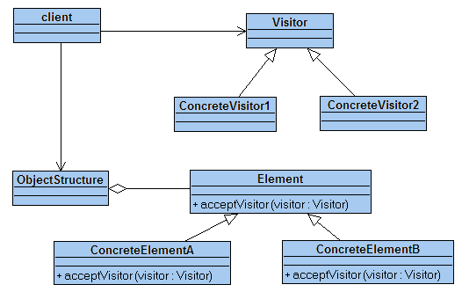

- Process
  - Agile development processes treat a product as a composition of several increments. How can they ensure that they have consistent error handling across the product?
  - What is the purpose of having ports on structural architectural elements, such as systems, processes, and threads, in AADL?
  - How can traceability be ensured in a software development product?
  - Where should cyclomatic complexity be used in the software development life cycle and what guidance does it provide?

- We are using these tools for our work: The Topcased editors for AADL and the use case, state, class, and sequence diagrams and EPF for process definition.
  - How are the scenarios from a use case captured in either AADL or UML(not the little ovals, the scenarios)?
  - We used the state machine diagram to capture fault models after a hazard analysis. Explain what the states and transitions represent in that use of the model.
  - How do SysML, UML, and AADL all add value to a development project? Describe how each separately contributes and then how they work in combination to improve a project.
  - The OPEN/CLOSED principle (A design is open for extension but closed for modification) is considered a good thing. What qualities does it enhance and which does it degrade? Why is it a good thing?

