CpSc 871
MidTerm Exam

Name________________________________

Answer any FOUR of the five questions. Place a large X on the page for the question you are not answering. If you answer all five, I will eliminate the one on which you did the best. All questions are counted the same: 25 points each. Be certain to answer ALL parts of the questions you select to answer. Answer the question that is asked and then stop. You are allowed the notes you have taken and printouts but no laptops.

- We have discussed several basic architecture styles.
  - Why did we use the MVC style for our computation application? In other words, which quality attributes were enhanced and which were degraded?
  - How does a layered architecture style enhance modifiability?
  - Describe one architectural view of our sample computational problem? Explain why that view is useful to the architect and to the person writing the code.
  - For a particular design problem there are usually several styles that will work. Describe the method for making a choice. What are the roles, tasks, and work products associated with that method of decision making?

- Modifiability was enhanced and latency degraded there is little communication between the model and view so the drop in latency is acceptable
- The style constrains the direction of dependencies and uses encapsulation to reduce complexity
- The developer of the model component needs a view that describes any parallelism in the implementation of the computation
- The architects make the choice of styles but other stakeholders contribute to prioritizing the qualities, priorities must be established and mapped to the styles to know which enhances the most qualities

- Requirements elicitation
  - Why is a use case approach to requirements elicitation better than the traditional approach of writing individual statements?
  - Why is it important to include many different stakeholders in the elicitation process?
  - Who would be the highest priority stakeholder for the computational system example? Why?
  - For purposes of security there is a requirement that all login mechanisms must use the same table of authorized users. How does this requirement flow from requirements to architecture design and on to detailed design and become an application of the Singleton pattern? What would happen at each step that makes it increasingly clear that Singleton is the correct pattern?
- The use case approach links direct actions by the users to features of the product
- Each stakeholder has information that no one else does
- The client
- The components of security are confidentiality, integrity and availability. As the requirement is incorporated into structures in the architecture the need to share the file raises its level of visibility and its scope but it must still be encapsulated.

- Design
  - The work breakdown structure in the definition of a process in EPF links roles, tasks, and work products. Describe how an entry in the work break down structure should look for using design patterns. (Not the actual appearance but what is the information in the entry?)
  - Give one risk for our computational example. Write the complete risk statement.
  - & d. Consider how Topcased maintains an xml-based file and a graphics file for each diagram. The Visitor design pattern could be used to implement the screen refresh operation of the graphical editor from the contents of the xml-based file. Given the Visitor pattern UML representation below, draw the classes and relationships that would be created for the graphical refresh. What would the Visitor represent and what would the Element represent?
- A top level heading such as “use design patterns” would have underneath it subtasks such as “Search design pattern catalogs”, “select candidate patterns”, “evaluate each pattern against qualities”
- {Don’t remember that example well enough. For the wireless charging …}There is a 40% chance that the efficiency of power transfer will be below acceptable limits requiring a 6 month delay while the hardware is redesigned.
- The Visitor would represent the drawing algorithm and the Elements would be the xml clauses representing individual graphical elements
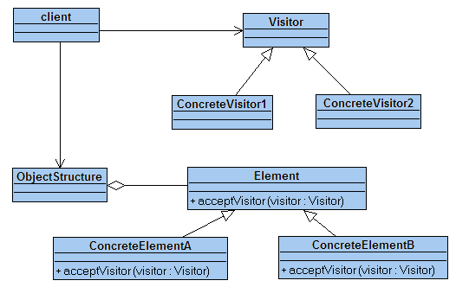

- Process
  - Agile development processes treat a product as a composition of several increments. How can they ensure that they have consistent error handling across the product?
  - What is the purpose of having ports on structural architectural elements, such as systems, processes, and threads, in AADL?
  - How can traceability be ensured in a software development product?
  - Where should cyclomatic complexity be used in the software development life cycle and what guidance does it provide?

- There needs to be architectural views that define error flows that run end-to-end in the system. Each increment must correctly implement that protion of the architecture
- A port provides an architectural element that can describe constraints on the flow in and out of the component such as the type of the values being passed.
- Traceability can be included in the process with explicit roles and tasks to record the transformation from one to the other. The mapping can also be explicitly in some artifacts such as using the same names for methods in an implementation as for ports in the architecture.
- Cyclomatic complexity can first be used to evaluate dependencies in the architecture and then in the code. It shows areas that are relatively more complex.

- We are using these tools for our work: The Topcased editors for AADL and the use case, state, class, and sequence diagrams and EPF for process definition.
  - How are the scenarios from a use case captured in either AADL or UML(not the little ovals, the scenarios)?
  - We used the state machine diagram to capture fault models after a hazard analysis. Explain what the states and transitions represent in that use of the model.
  - How do SysML, UML, and AADL all add value to a development project? Describe how each separately contributes and then how they work in combination to improve a project.
  - The OPEN/CLOSED principle (A design is open for extension but closed for modification) is considered a good thing. What qualities does it enhance and which does it degrade? Why is it a good thing?

- In UML a sequence diagram or an activity diagram will show a scenario. In AADL the flows show a group of scenarios per flow
- A state represents a fault and a transition represents arriving at a fault through some program action
- Notations give a concrete realization of the design thoughts of the team. SysML is a high level system wide representation, UML is a more detailed design level view of the software and AADL provides the bridge bwteen the two by taking a system wide view of the software design
- Enhances extensibility and flexibility and degrades complexity by requiring a more complex architectural mechanism than a totally static design would

