CpSc 871
MidTerm Exam

Name________________________________

Answer any FOUR of the five questions. Place a large X on the page for the question you are not answering. If you answer all five, I will eliminate the one on which you did the best. All questions are counted the same: 25 points each. Be certain to answer ALL parts of the questions you select to answer. Answer the question that is asked and then stop. You are allowed the notes you have taken and printouts but no electronics such as laptops, phones, etc.

- We have discussed several basic architecture styles.
  - The SDK begins with a default architecture of MVC. Why is that a valid assumption? (Be specific)
  - AADL uses the “annex” concept. Give two reasons why. What software engineering properties does this enhance for the language?
  - The plug-in architectural style is used to describe the connection of an app to the platform it is extending. How does this appear in the structure of an Android app?
  - Give one complete quality attribute scenario for your app. Explain how this scenario affected the architecture.
- Apps require interaction with the ser which is the strength of MVC
- Annex modularizes the definitions. Each annex is a cohesive unit that by its name tells whether you need it and whether a behavior you are about to add belongs or not.
- The callback functions such as onClick establish the connection and the structured xml data that is read and used at startup time.
- Answer varies but must include all fields.

- Requirements
  - Use cases, feature models, and English sentences are all used to communicate requirements. What are the strengths and weaknesses of each notation?
  - During requirements elicitation we collect requirements stakeholder by stakeholder. How does the requirements analysis task regroup and modify the requirements?
  - Who would be the highest priority stakeholder for your app? Why?
  - The architect decides on the style(s) to be used. What information in the requirements contributes to that decision?
- Use cases relate directly to the functional properties of the system and to several stakeholders but they do not integrate similar scenarios into one algorithm. Feature models allow for requirements for a set of products and allow mixing functional and non-functional req. but they do not tie to stakeholders so are not good for traceability. English sentences are flexible and can be used for everything but they are often vague and ambiguous.
- The analysis groups similar functions together so that we can trace a stakeholder’s requirements to the implementation of the product.
- Answer varies
- Mainly the non-functional requirements but within a specific domain some architecture patterns are used more than others.

- Design
  - How is the Liskov Substitutability Principle useful in a software product line?
  - Give one risk for your app. Write the complete risk statement. Describe one design decision that could mitigate some of that risk.
  - & d. The Adapter pattern relates to making the interfaces of modules compatible. If we are using a design by contract strategy, what responsibilities does the Client have with respect to the interface of the Target and what responsibilities does the Target have? How do the responsibilities of the Target affect the Adapter and Adaptee?
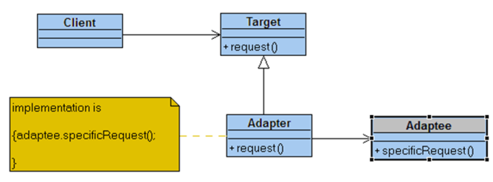
- Generalization in which one subtype can be substituted for the abstract base type provides one variation mechanism.
- Answer varies but must include the event, probability of occurrence, and consequence.
- The Client checks the precondition for the request method. The Adapter is a direct substitute for the Target so same responsibilities at least.

- Process
  - Development of all types of software products go through the same basic steps: requirements, architecture, design, implementation, and testing. How are the processes different between a life critical product and an entertainment product?
  - In OSATE we create AADL descriptions of an architecture and then apply tools to either that architecture definition or to an instance of the architecture. What can we analyze about the generic architecture definition and what is different about what can we analyze about an instance?
  - The Software Process Engineering Meta-model defines roles, tasks, workproducts, and guidance as the fundamental elements needed to define a process. Give examples of each in the process for the building of a life critical app.
  - Tools such as cyclomatic complexity can be used during architecture design and implementation. What is the same about its use at these two different points in the development process and what is different?
- The amount of detail such as the level of test coverage changes. The outputs for each step are developed more specifically to ensure clear communication.
- The generic is static and so structure and structural qualities can be analyzed while the instance is dynamic and both the structure and the dynamic properties such as performance can be analyzed.
- Role – a reviewer of design documents; tasks – conduct architecture evaluation; workproduct – the architecture model being reviewed
- The same basic graph traversal algorithms can be used but with different interpretations.

- Fundamentals
  - The act of abstracting involves removing detail. Relate this to using AADL to represent the architecture of a product.
  - The state machine formalism is used in many ways including in the error annex of AADL and in controller designs in MVC. What qualities about the architecture does the use of this formalism emphasize?
  - Liskov’s Substitutability Principle is a fundamental principle in object-oriented programming. How does this Principle enhance flexibility?
  - The modules in a product must be coupled to some degree for the product to perform its functions, but too much is a bad thing. Likewise a module must be cohesive but not to the point that every method calls every other method. What criteria does the designer use to tradeoff coupling and cohesion between modules to know when they have the best design?
- The AADL syntax provides a specification without providing an implementation.
- Moving from one discrete configuration of data to another due to a specific action.
- By allowing substitutions without rewriting the logic or recompiling the program.
- Modularity and complexity

